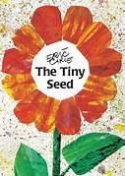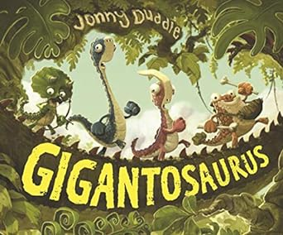 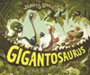

**Personal, Social and Emotional Development**

**Self-Regulation**

-Children will know how to show resilience and perseverance in the face of challenge.

**Managing Self**

-Children will know what a sensible amount of screen time is and why this is important for their health.

**Building Relationships**

-Express their feelings and consider the feelings of others.

-Think about the perspectives of others.

**Expressive Arts and Design**

**Being Imaginative and Expressive**

-Sing in a group or on their own, increasingly match the pitch and following the melody.

-Listen attentively, move to and talk about music, expressing their feelings and responses.

-Big Bear Funk in Charanga

**Creating with Materials**

-I know how to join materials using sellotape, masking tape, PVA glue, hole punches and treasury tags and split pins.

-I will explore and recreate art in the style of **Georgia O’Keefe** (flowers).

-I know how to use watercolour paints to make paler and darker colours.

-I know how to mix watercolour paints.

**Understanding the World**

**People, Culture & Communities**

-I know that some places are special to some members of the community of Malpas, such as the church.

-I know that Christians go to church.

-Invite visitors in from different religious and cultural communities.

- I can explore, notice and describe things in my village.

-I can talk about where I live.

-I can talk about how I travel to school.

-I can draw a simple map of my village.

**The Natural World**

- Describe what they see, hear and feel whilst outside.

-Explore the natural world around them.

-I know how to care for a plant including watering them and giving them sunlight.

- I know caring for plants will make them grow.

- I can recognise familiar plants.

**Reception**

**Medium Planning**

**Summer Term 1**

**Maths**

-Counting – larger sets and things that cannot be seen

-Subitising – to 6, including in structured arrangements

-Composition – ‘5 and a bit’

-Composition - of 10

-Comparison – linked to ordinality

-Play track games

**Shape, Space and Measure**

- Tangrams

- Match the shape pictures and models

- Repeating patterns- ABBA

**Physical Development**

**Gross Motor**

**-**Combine different movements with ease and fluency

-Progress towards a more fluent style of moving, with developing control and grace

-Develop overall body-strength, balance, co-ordination, and agility- Sports Day skills

**Fine Motor**

**-** Children will know how to correctly form lower-case letters.

**Communication and Language**

**Listening, Attention and Understanding**

-Ask questions to find out more and to check they understand what has been said to them.

**Speaking**

-Articulate their ideas and thoughts in well-formed sentences.

-Use new vocabulary in different contexts.

-Use talk to help work out problems and organise thinking and actions.

-Explain how things work and why they might happen.

-Connect one idea or action to another using a range of connectives.

-Re-tell the story once they have developed a deep familiarity with the text: some as exact repetition.

-Children will know and retell the story ‘**Gigantosaurus’**.

**Literacy**

**Comprehension**

-Children will read and re-read a selection of books fluency, understanding and enjoyment.

**Word Reading**

-Read simple phrases and sentences made up of words with known letter sound correspondences and, where necessary, a few exception words

-Read a few common exception words matched to the school’s phonic programme

-Re-read these books to build up their confidence in word reading, their fluency and their understanding and enjoyment.

**Writing Composition**

Fiction

-To rewrite the story.

-To write a shortened version of the story.

-Use phonic knowledge to write words in ways which match spoken sounds.

-Spell some common irregular words. Write simple sentences which can be read by themselves and others

-Apply taught digraphs and trigraphs into writing. Write words with adjacent consonants.

**Writing Transcription**

-Form lower-case and capital letters correctly.

-Spell words by identifying the sounds and then writing the sound with letters.

-Write short sentences with words with known sound-letter correspondences using a capital letter and full stop.

-Re-read what they have written to check that it makes sense.

**Terrific books:**

Red Rockets and Rainbow Jelly

The Runaway Pea

Never Show a T-Rex a Book

Dinosaur Roar

How Big is a Million?

Gingerbread Man

White Hen and the Fox

Are the dinosaurs dead, dad?

Billy and the Beast

Volcanoes- non-fiction

The Big Book of Dinosaurs- non-fiction

**Poems:**

-Dinosaur, dinosaur, turn around

-A dinosaur went stomping one day

-I want to be a great big dinosaur