MALPAS ALPORT ENDOWED PRIMARY SCHOOL

Attendance Policy

Approved by Governing Body | Autumn 2023
Next Review Date | Autumn 2024
Signed | AJones

MALPAS ALPORT ENDOWED PRIMARY SCHOOL ATTENDANCE POLICY

Introduction and Aim

Malpas Alport Endowed Primary School recognises the importance of good attendance and the impact it has on children’s progress, attainment, enjoyment of learning and relationships within school. Good attendance helps a child to realise their potential and ensure they are motivated, confident and enjoy a diverse range of curricular opportunities and experiences. Our school policy and prospectus promote good attendance, which is recognised and rewarded as an achievement. The school monitors attendance and ensures quick and early intervention if a problem is identified. We recognise that whole school preventative and proactive approaches are key to promoting children wellbeing and attendance. A child must attend school every day that they are required to do so unless an exceptional circumstance applies.
Our policy is accessible to leaders, staff, pupils, and parents, and is published on our school website. It will be sent to Parents with any initial information when pupils join the school and reminded of it at the beginning of each school year and when it is updated. As the barriers to attendance evolve quickly, the policy should be reviewed and updated as necessary. In doing so, we will seek the views of pupils and parents. The Attendance & Punctuality Policy is based on the premise of equal opportunities for all.

Legislation

Education Act 1996 section 444
Children Act 1989 ESO (paragraph 18(1), Schedule 3, Children Act 1989
Anti-social Behaviour Act 2003

School Attendance Prosecutions
If a parent fails to get their child to regularly attend school, the School and the Local Authority (LA) should make reasonable efforts to resolve the problem before resorting to legal action. If, however, it becomes apparent that all other avenues have been explored, the information below gives information regarding the legal landscape the offences fall within.
The offences
LAs have the power to prosecute parents who:

- Fail to ensure their child’s regular attendance at school (section 444, Education Act (EA) 1996)
- Knowingly allow their child to be absent from school without authorisation (section 444(1A), EA 1996)
- Persistently fail to comply with directions given under an Education Supervision Order (ESO) ((paragraph 18(1), Schedule 3, Children Act 1989)
Only the LA can prosecute parents for the offences found in section 444 of the Education Act 1996 (section 446, EA 1996) and they must fund all associated costs.

Failure to ensure a child’s regular attendance at school (sec 444(1))
Parents are guilty of an offence for failing to ensure that their child regularly attends school (section 444(1) and (ZA), EA 1996).
With regards to the section 444(1) offence, the LA will need to prove to the criminal standard that the child is a registered pupil at a relevant school and that he is of compulsory school age and has failed to regularly attend school without authorisation. The only evidence that the LA will need to provide the court with, is the certificate of attendance and why an Education Supervision Order (ESO) is not appropriate.

Knowingly allowing a child to be absent from school without authorisation (sec 444(1A))
It is regarded as a more serious offence when a parent knowingly allows a child to be absent from school without authorisation (section 444(1A), EA 1996). In such circumstances, the LA will need to show that the child failed to regularly attend school without authorisation, and that the parents knew and failed, without reasonable justification, to ensure that their child regularly attended school.

The EA 1996 does not define “reasonable justification” but case law tells us that it is to be approached as a perfectly understandable English expression and that it was unnecessary for every single avenue to be explored to ensure that a child received “schooling”, as that was immaterial to attendance at school. ‘Reasonable justification” seems to be a question of fact relating to the child’s attendance at school and is, therefore, to be looked at in that context.
Regular attendance
The essential element in both the offences under sections 444(1) and 444(1A) of Education Act 1996 is whether the child has regularly attended school. While the term “regular attendance” has been in use since the Education Act 1944, there is no statutory definition of it.

The Supreme Court in the ‘Isle of Wight Case’ interpreted the word “regularly” in section 444(1) of the Education Act 1996, after having considered Parliament’s intention and the history of the requirement for parents to ensure their child’s attendance at school. The justices determined that “regularly” means at all times required by the rules prescribed by the school. “Full-time” education means all of the time when education is being offered to the child

Each school should have its own policy about what level of attendance it considers to be ‘regular attendance’ and when a Fixed Penalty Notice will be issued and when it will consider a prosecution. The acceptable attendance level may be different for each school.

Registers

Registers provide the daily record of attendance of all pupils. They are legal documents and the register may be required in a court of law, for example as evidence in prosecutions for non-attendance in school.

‘Education (Pupil Registration) (England) Regulations 2006’ (section 6)
School will take the attendance register at the start of the first session of each school day, morning (a.m.) and once during the second session, afternoon (p.m.).

On each occasion they must record whether every pupil is:
• Present
• Attending an approved educational activity
• Absent
• Unable to attend due to exceptional circumstances.

The school will follow up any absences to:
• Ascertain the reason
• Ensure the proper safeguarding action is taken
• Identify whether the absence is approved or not; and,
• Identify the correct code to use before entering it on to the school’s electronic register, or management information system as a priority and returned to the school office in a timely manner. This is used to download data to the School Census.
- Consider early identification, assessment, intervention and support processes that may need to be implemented.

The register will be marked using the codes as advised by the Department for Education (DfE) ‘Working together to improve School Attendance Guidance’ (for maintained schools, academies, independent schools and local authorities) https://assets.publishing.service.gov.uk/government/uploads/system/uploads/attachment_data/file/1073616/Working_together_to_improve_school_attendance.pdf (See appendix 3.)

Procedure

Children are expected to attend school regularly, unless there is good reason for absence.
There are two types of absence:
- Authorised (where the school approves a pupil absence)
- Unauthorised (where school will not approve the absence)

The school has a duty to safeguard all its pupils. If a child is absent, the parents/carers should inform the school via the main school office on 01244268600 on the first day of absence and each following day of absence, clearly stating the reason. This should be either a phone call or a voice message. Parents are asked not to email regarding absence
The school office will make contact with home when a child is absent, and the parent/carer has not notified the school of the absence. If no contact can be achieved or the reason for absence is not accepted the absence will be unauthorised.

Persons responsible for attendance in Malpas Alport Endowed Primary School
- Nic Wetton Head Teacher – overall attendance lead
- Vicki Williams Deputy Head Teacher - Strategic attendance lead/champion
- Ashley Tilley/Terri-Ann Reynolds - first day contact link
- Arwyn Jones – Chairman of Governors

What can parents/carers do to help and working in partnership with Parents/ Carers

Let the school know straight away why your child is absent. Home/school communication is
extremely important in supporting your child to achieve and feel settled in school. Try to make any dental/GP appointments outside of school time.

As a school we recognise that building respectful relationships with families and working in collaboration is essential to ensuring the best outcomes for children / young people. We require all parents to actively support the work of the school, including promoting attendance and engagement. We are committed to ensuring that systems and processes are in place with regards to promoting attendance and would encourage parents to make contact if they have concerns about their child.

We will provide parents / carers with information about Emotionally Based School Non-attendance to discuss needs and strategies to support their child, as appropriate (see EBSN Parent Leaflet).

It is pertinent that school and parents / carers work together with a shared plan and outcomes when supporting a child / young person’s attendance and wellbeing. If despite persistent attempts to work with parents, there continues to be a lack of engagement, then legal procedures may be followed to secure engagement and school attendance.

Absence Monitoring

School robustly monitor and analyse attendance data to promptly identify and address possible concerns and allow for early interventions to support the child/family’s underlying needs. This will include –
- Weekly attendance code analysis
- Specific cohort and group monitoring – particularly for vulnerable groups i.e. children with a social worker
- ‘Welcome back’ meeting for all pupils that have been absent for 5 days – to check wellbeing and ensure there are no ongoing needs that will impact on attendance
- The school’s strategy for using data to target attendance improvement efforts to the pupils or pupil cohorts who need it most.
- The school’s strategy for reducing persistent and severe absence, including how access to wider support services will be provided to remove the barriers to attendance and when support will be formalised in conjunction with the local authority.

Early Identification and Intervention: assess, plan, do and review

Every pupil has a right to a full-time education and Malpas Alport sets high attendance expectations for all pupils. Malpas Alport will consider the individual needs of pupils and their families who have specific barriers to attendance and will consider our obligations under the Equality Act 2010 and the UN Convention on the Rights of the Child.
For any child / child person who is absent from school it is essential to fully understand the reasons for this so that targeted, evidence-based interventions and support can be put into place. All staff have a part to play in promoting attendance. We recognise the importance of ensuring that key members of staff from across the school, including Form Tutors, attendance, pastoral and SEND staff work in collaboration to consider and identify the holistic needs of the child/young person and to overcome barriers to attendance. In accordance with the principles of early intervention, a graduated approach of assess, plan, do and review will be followed utilising a arrange of school-based resources, evidence-based interventions and seeking advice and support from external services at an appropriate stage, when needed.

Appropriate assessments will be important to help understand the underlying reasons that may be contributing to attendance difficulties. This may be an assessment that focuses on the individual child’s needs such as an SDQ, SEND assessments and wellbeing assessments or may include the holistic needs of the family, such as a TAF assessment. Assessments will include the views of the child/young person as well as parents/carers, and identify strengths (what is working well) and needs (what is working less well).

Assessments undertaken may identify that a child/young person is experiencing underlying emotional based needs that are contributing to non-attendance. Cheshire West and Chester Council has developed guidance for schools - Emotionally Based School Non-attendance: Good practice guidance for schools (revised November 2021). This is a whole school framework with a graduated approach to support the early identification and intervention of children/young people who may struggle to cope in school/attend school.

Information from assessments will inform a SMART action plan with focussed targets developed in partnership with families, and other services as appropriate. For example, Early Help and Prevention and Social Care may have a part to play in the delivery of support and intervention to promote engagement and attendance. SMART plans should be personalised to effectively meet a child / young person’s needs and improve attendance and wellbeing outcomes.

Regular reviews of support and attendance plans are essential to monitor the impact of interventions and to adjust these accordingly. If, despite targeted support and intervention, attendance and wellbeing concerns persist, we may seek further advice and support from external services including mental health services, specialist teaching and education services.

Promoting and Incentivising Attendance (Rewards and Incentives)
Rewards, incentives and competitions play an important part when working to improve attendance. As a school, we consistently promote the benefits of good attendance. Our aim is that rewards and incentives are purposeful and meaningful.

There are many different barriers that pupils and families may be faced with which prevent them from attending school regularly. As a school, we work closely with families to build strong relationships, in order to identify and help remove these barriers. Rewards and incentives play an important part when working with families and individuals., Where a pupil or family needs support with attendance, we ensure that the best placed person in the school works with and supports the family and wherever possible the person is kept consistent.
At Malpas Alport, we use a Trauma Informed Approach when managing attendance and this is embedded across the school’s practise and attendance policy.
We have display in main hall to promote good attendance and half termly attendance newsletters are sent out to highlight the key factors, impact, what to do if, leaflets, expectation etc.
Every week we promote excellent attendance by rewarding the classes with attendance over 96%. We also have other incentives such as certificates and individual incentives where needed.

Medical Absence
Schools should advise parents to notify them on the first day the child is unable to attend due to illness. Schools must record absences as authorised where pupils cannot attend due to illness (both physical and mental health related)
In the majority of cases a parent’s notification that their child is ill can be accepted without question or concern. Schools should not routinely request that parents provide medical evidence to support illness. Schools are advised not to request medical evidence unnecessarily as it places additional pressure on health professionals.
Only where the school has a genuine and reasonable doubt about the authenticity of the illness should medical evidence be requested to support the absence. In instances of long-term or repeated absences for the same reason, however, seeking medical evidence may be appropriate to assist in assessing whether the child requires additional support to help them to attend more regularly, and whether the illness is likely to prevent the child from attending for extended periods. If a parent proactively seeks out a note from a GP, it does not imply a need for absence unless this is explicit in their letter.
If a medical absence is likely to be ongoing or long term, then the school should offer support in accordance with the school’s policies and statutory guidance relating to Children with health needs.
Schools must provide information to the Council about children who are not attending school for reasons of illness, health or otherwise, which is expected to last for 15 school days or more.
Mental health issues affecting a pupil's attendance: guidance for schools - GOV.UK (www.gov.uk)
Medical Needs
For children who have a medical condition and cannot attend school, the school will refer to the Cheshire West and Chester Council’s Medical Needs Team.
Education of children and young people with medical needs | Cheshire West and Chester Council
Their policy states that referrals must come directly from the child’s school and must be supported by medical evidence from one of the following health professionals:
- consultant paediatrician or adolescent psychiatrist
- consultant child psychiatrist
- hospital consultant
Supporting evidence from a General Practitioner alone cannot be accepted, although whilst mental health services have long waiting lists, the team will consider GP evidence.
Mental Health
Parents/carers have a duty, under section 7 of the Education Act 1996, to ensure that their child of compulsory school age (5 to 16) receives an efficient full-time education either by attendance at school or otherwise, and so share in the responsibility of ensuring good and regular attendance.
As such, we encourage parents/carers and schools to be open and work together with us to create a plan for attendance that fits with the needs of the child. As a school, we work with parents/carers and pupils to understand the barriers to their attendance and, where appropriate, making reasonable adjustments to overcome those specific barriers is an effective way of building confidence and reducing anxiety about attending.
Parents/carers should engage with support offered by the school, are reminded of the importance of regular attendance and the emotional and mental wellbeing benefits of attending school for children and young people. Any reasonable adjustments or support put in place by school will ensure that the time the child spends in school is prioritised as much as is possible.
In some instances, parents/carers themselves might be living with mental health problems or experiencing wider vulnerabilities or challenging life circumstances. This may affect their ability to provide support and care, so we recognise the need for practical, whole-family support and/or early help support where necessary, in order to try to address the causes of poor attendance.
Where support offered is not engaged with, or where all other options have been exhausted or deemed inappropriate, school will work with the local authority to consider whether to formalise support or to enforce attendance through legal intervention in the normal way under their existing powers and when to inform the Local Authority about an attendance concern.
It is important that children and parents/carers do not feel as though their concerns about mental health have gone unheard which is why we record absences as authorised where pupils of compulsory school age cannot attend due to illness (both physical and mental health related).
As a school, we will not routinely ask for medical evidence to support recording an absence as authorised for mental health reasons. This is because, in general, primary care health professionals such as General Practitioners are unlikely to be able to offer such evidence to support one-off absences related to mental health.
In instances of long-term or repeated absences for the same reason, however, seeking medical evidence may be appropriate to assist in assessing whether the child requires additional support to help them to attend more regularly, and whether the illness is likely to prevent the child from attending for extended periods. If a parent proactively seeks out a note from a GP, it does not imply a need for absence unless this is explicit in their letter.
Lateness and Punctuality

School begins at 8:45amand all pupils are expected to be in school for registration at that time.

- Register taken at 8:45am
- Registers close 8:50am

Any child who arrives after the gates are closed must enter the school by the main entrance and report to the school office to sign in. If pupils are not in class when the register is in class is closed, they will be coded as ‘L’. Any late arrivals after 9:15am will be coded as ‘U’ which is an unauthorised absence for that session.

In accordance with the ‘Education (Pupil Registration) (England) Regulations 2006’, if your child arrives after the registers close, they will receive a mark, code U, that shows them to be on site, but this will not count as a present mark and it will mean they have an unauthorised absence. This may mean that you could face the possibility of a Fixed Penalty Notice or other legal action if the problem persists.

Children who are consistently late for school are disrupting not only their own education, but also that of other children. Where persistent lateness gives cause for concern, you will be invited to a meeting to resolve the issues. If there is no improvement following this meeting, further action will be taken which may include referral to external agencies.
You may approach the school at any time for support and advice if you are having difficulty getting your child to school on time or maintaining regular attendance.

Unauthorised Absence and Fixed Penalty Notice

An absence may be coded as ‘unauthorised’ if:
    - no reason for absence has been given
    - medical evidence is not received when requested
    - a request for a leave of absence has been unauthorised
    - a pupil arrives at school after registration has closed at 9:15am

Parents/carers should be aware that Malpas Alport may contact the Local Authority if a pupil has 10 or more unauthorised absences in the current term with a view to issuing a Fixed Penalty Notice or other legal action. The Fixed Penalty Notice is issued individually to each parent/carer who fails to ensure their child’s regular attendance at school. The Penalty is £60 per parent/carer per child if paid within 21 days rising to £120 if paid within 28 days. Non-payment of the Fixed Penalty Notice may result in prosecution in the Magistrates court (see appendix 1).

Application for Exceptional Circumstances

In September 2013, amendments to the Education (Pupil Registration) (England) Regulations 2006, make it clear that Head Teachers may not grant any Leave of Absence (holiday) during term time unless there are ‘exceptional circumstances’

The Head Teacher and the Governing Body will determine what constitutes an exceptional
circumstance on an individual basis. If parents/carers need to request Exceptional Leave of Absence, they must complete an ‘Exceptional Leave of Absence’ form available from the school office. It should be noted that if any application is declined and absence occurs of a consecutive 5 or more unauthorised days, then school may apply to the Local Authority for a Fixed Penalty Notice to be issued to each parent/carer.

The following will not be deemed to be exceptional circumstances:
- Family holiday
- Availability of less expensive holiday
- Availability of holiday accommodation
- Parent/carer’s working commitments
- Holiday pre-booked by another family member

A child’s absence during term time seriously disrupts their continuity of learning. Not only do they miss the teaching on the days they are away but are less prepared for the lessons building on that teaching when they return to school. There is a consequent risk of under achievement, which we must seek to avoid.
The Governing Body is responsible for ensuring any attendance issues are dealt with in line with school policy.

Religious Observance

We recognise that some pupils may need to participate in days of religious observance.
Where a day of religious observance.

- falls during school time and
- has been exclusively set apart for religious observance by the religious body to which the pupil belongs
We ask that parents/carers notify Malpas Alport in writing in advance where absence is required due to a religious observance.

Enforced School Closure

If Malpas Alport was forced to close for a period of time, we have the facility to operate an
online virtual school. The expectation is children will still engage with ALL activities when work is set. Procedures for online learning will be sent to parents as and when required.

Impact
All pupils will achieve well by developing knowledge and skills on their journey through school. Due to robust monitoring of attendance, all pupils, including vulnerable children and children with special educational needs and disabilities (SEND), will have fair and equitable access to school in order to achieve the best possible outcomes. Pupils will leave Malpas Alport ready for a successful transition to secondary education.

Review of Policy

- This policy reflects the latest government guidance on school attendance and will be reviewed annually.
- The principles of this policy will be raised in the school newsletter regularly throughout the year
- Any complaints arising from the implementation of this policy should be addressed to the Head Teacher in the first instance

Appendix 1

The table below sets out the attendance targets and at what stage parents/carers will be contacted about their child’s attendance.
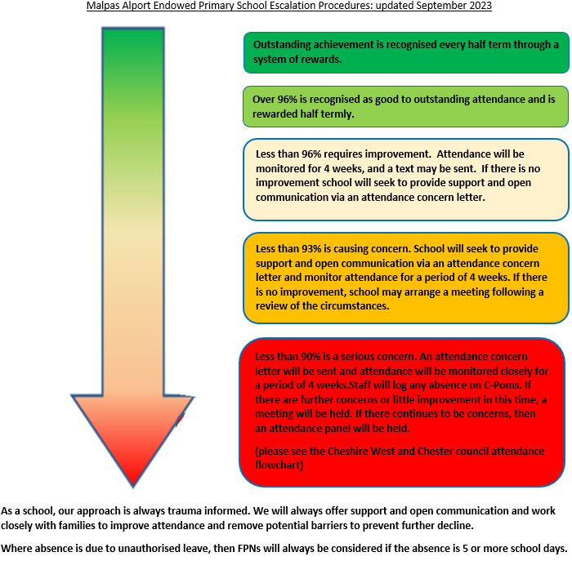
See appendix 2 for further breakdown of missed sessions.

Appendix 2

What does ‘percentage attendance’ mean?
Parents/carers should be advised that from September 2015 the Government have categorised those pupils who have attendance of 90% and below as ‘Persistent Absence’ pupils (P.A.). RSA will be specifically targeting this cohort of pupils, in an effort to improve their attendance in the future. The table below shows the learning time lost against percentage attendance figures.
Attendance during one school year | Equivalent  Days | Equivalent  Sessions | Equivalent  Weeks | Equivalent Lessons  Missed
95% | 9 Days | 18 Sessions | 1.4 Weeks | 45 Lessons
90% | 19 Days | 38 Sessions | 3.4 Weeks | 95 Lessons
85% | 29 Days | 58 Sessions | 5.4 Weeks | 145 Lessons
80% | 36 Days | 72 Sessions | 7.1 Weeks | 180 Lessons
75% | 48 Days | 96 Sessions | 9.3 Weeks | 240 Lessons

Appendix 3
Cheshire West & Chester Code of Conduct for Education Fixed Penalty Notice (Unauthorised Leave of Absence & Irregular Attendance)
1. A Fixed Penalty Notice (FPN) can only be issued in cases of unauthorised absence.
2. A maximum of two FPNs may be issued in an academic year and these FPNs may be issued against each parent/carer of a child. Once two FPNs have been issued, should there be further unauthorised absences, the Local Authority are able to move to prosecution immediately.
3. A FPN may be issued per parent per child.
4. Penalty Notices may be considered appropriate if:
- Unauthorised absences of at least 10 consecutive school sessions (five school days).
- Sessions either side of a weekend or school holiday will be counted as consecutive school days.
- For poorly attending learners, at least 10 sessions (five school days) lost due to unauthorised absence during a school term. These do not need to be consecutive.
- For poorly attending learners, persistent late arrive at school in a term. Persistent means at least 10 sessions of late arrival.
- The presence of an excluded child in a public place in the child’s first five days of exclusion.
6. The school must notify parents of the Attendance Policy and clearly state that parents may receive an FPN for an unauthorised leave of absence relating to holiday in term time.
7. Schools and the Education Welfare Services will take into account any exceptional circumstances when determining whether to issue a FPN.

Appendix 4
Absence Codes:
According to the DfE guidance the following codes are used on the register.

Code I | Illness | Schools can request medical evidence from parents/carers if they feel the authenticity of an illness is in doubt.
Code M | Medical or dental appointments | Parents/Carers are encouraged to arrange appointments out of school hours but the school will authorise if confirmation of the appointment is provided.
Code C | Other circumstances | This code will be used for any authorised non-medical reasons for a child’s absence from school, i.e. – family funeral.
Code D | Dual Registered | This code will be used if a pupil is registered at two schools.
Code J | Interview | This code will be used when it has been agreed that the pupil can miss school to attend an interview or entrance exam
Code P | Approved sporting activity | This code will be used in times of approved sporting activities in school times, i.e. – training sessions, trials and sporting events.
Code R | Religious Observation | This code is used to cover major religious festivals during term-time. The school will only authorise one day absence for religious events.
Code V | Educational visits and trips
Code W | Work Experience
Code G | Family holiday not authorised by the school or in excess of agreed period
Code U | Arrived late to school after 9.30am
Code N | Reason for absence not yet provided
Code O | Absent from school without authorisation
Code X | Not required to be in school (not compulsory school age)

Appendix 5
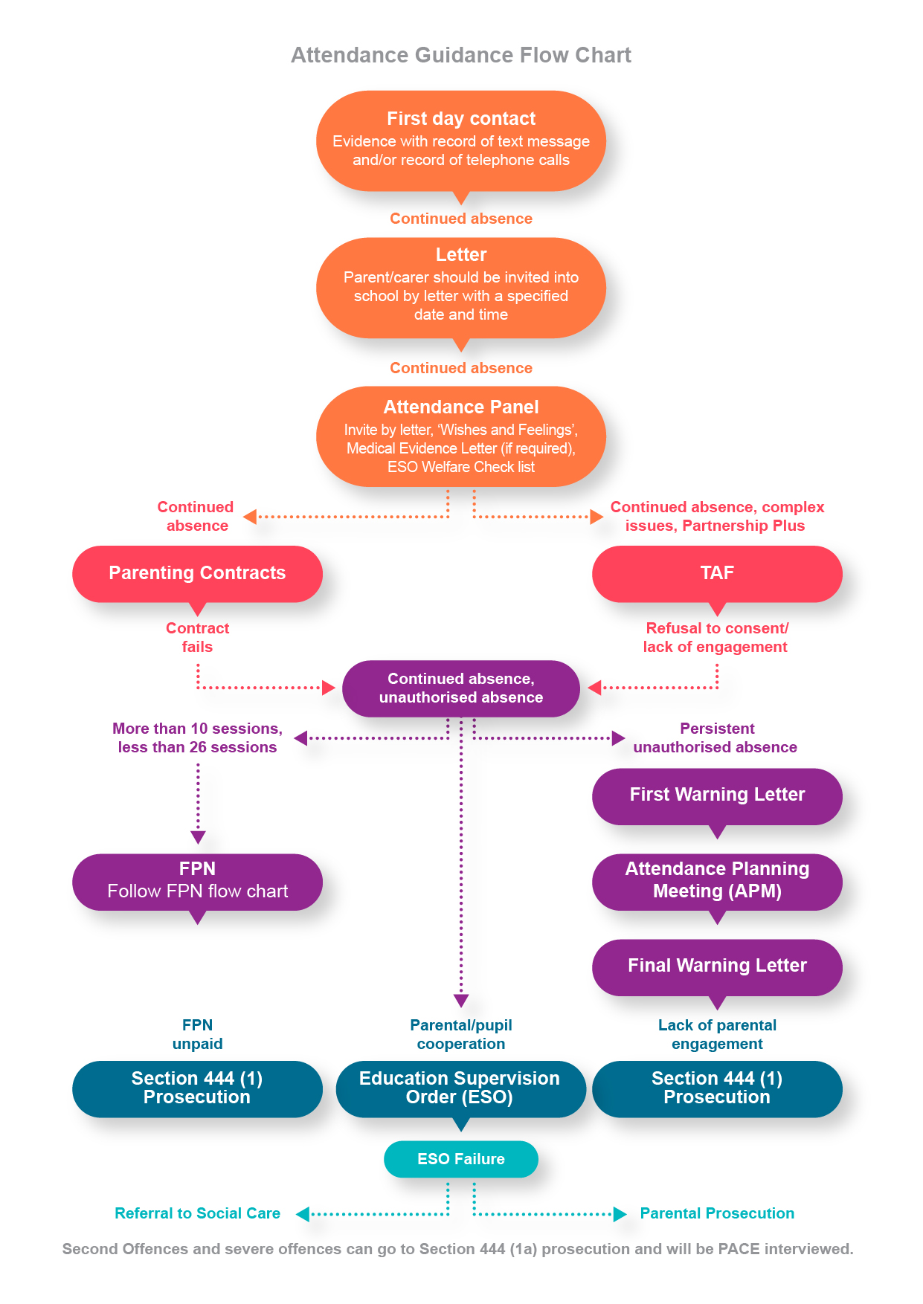

Appendix 6

Emotionally Based School Non-attendance (EBSN)
Emotionally Based School Non-attendance (EBSN) is a term used to describe the needs of CYP who struggle to attend school due to underlying emotional based needs, such as anxiety, unhappiness and despair. These CYP may be reluctant to leave home and can present high levels of distress in response to parents’ attempts to get them to school. This can result in prolonged absences from school.
EBSN is complex and multifaceted, requiring a holistic approach to assessment and intervention. Good practice guidance emphasises the importance of early identification and intervention to support the needs of CYP who may struggle to attend school, developing a SMART support plan, with timely review processes (CW&C, 2018).
The EBSN framework is embedded within the school’s Attendance Policy and we use many of the tools and resources to underpin our early identification of need and targeted support and intervention approach.
Schools can access EBSN training and Guidance (EBSN: Good Practice Guidance for Schools) via: eCWIP for Education - Cheshire West Industry Professionals

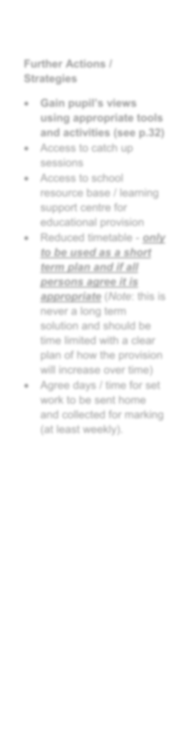
MALPAS ALPORT EBSN PATHWAY
First day contact
Picked up through monitoring/concerns shared
Concern letter 1 sent
Weekly punctuality / attendance monitoring

Continued absence: Letter
ATTENDANCE GUIDANCE FLOWCHART
Phase 1 – Well-being and attendance monitoring,
information and evidence gathering
Responsibility: School

Phase 2 – Acknowledgement
Letter to invite parents into school for a meeting with a specified date and time
Responsibility: School, Parent / Carer
Phase reached if parent informs school of concern in getting their child
to attend or in relation to their child’s emotional health and wellbeing;
or school identifies the same concerns.

Attendance panel
Invite by letter, ‘wishes and feelings’
Medical evidence letter (if required)
ESO welfare checklist

Phase 3 – Continued Concerns
Responsibility: School, Parent / Carer, named person with responsibility
for attendance

Parenting contracts or TAF
Phase 4 – Multi-agency Action Plan and Review
Responsibility: School, Parents / Carers, named person with responsibility
for attendance and other agencies involved

More than 10 sessions, less than 26 sessions: FPN (follow FPN flowchart)
Persistent unauthorised absence:
Attendance planning meeting (APM)
Phase 5 – Further Action Plan Implementation and Review
Responsibility: all parties involved in TAF
Continued monitoring, implementation and review:
FPN unpaid-section 444 (1) prosecution
Parent/pupil cooperation- Education Supervision Order (Eso)
Lack of engagement: Section 444 (1) prosecution

Phase 6 – Continued Non-attendance due to EBSN
Responsibility: School, Parent / Carer, Local Authority and all other
ESO failure: social care/prosecution
appropriate agencies

