***Do you know the 7 elements of art?***

***Can you explain each one?***

***Can you use them in your artwork?***

**Space:**

Space is the area around or between objects.

Space includes the background, foreground, and middle ground.

A space can be negative (focusing on the background) or positive (focusing on the main object).

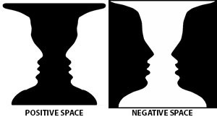

**Texture:**

Texture refers to the surface quality of something, and the way it feels. Actual texture really exists, and you are able to touch it e.g. the texture of different fabrics in a collage.

Visual texture is an illusion of texture, created using lines, shapes, colours or tones. A texture can look different to how it really feels e.g. a drawing of a sheep might look fluffy, but the paper feels smooth to touch.

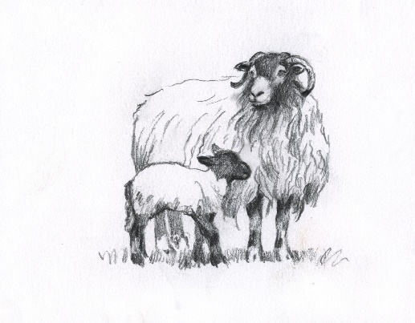

**Value:**

**Line:**

A line is a mark that is longer than it is wide. A line could be created using materials such as a pencil, pen, or a brush dipped in ink.

A line can be straight or curved. It can be horizontal, vertical or diagonal, and can change direction.

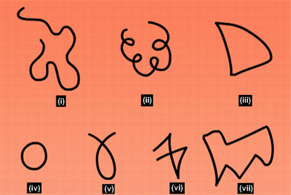

**Shape:**

A shape is flat and is created by a closed line. The shape might be an outline or filled in with solid colour, shading, or a pattern.

Shapes can be geometric, like squares or triangles.

They can also be irregular, or natural shapes such as puddles or leaves.

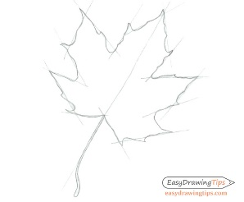

**Value:**

Value is the lightness or darkness of a colour.

High value is light with white being the highest.

Low value is dark, and black is the lowest.

Using different values creates contrast, which helps the viewer to see and understand the image, such as in a black and white photograph.



**Form:**

Form is a three dimensional shape. It may be a regular shape, such as a cube or pyramid, or an irregular, organic shape. Form can be expressed in 3D, such as in a sculpture.

Artists can also use tone and perspective to create an illusion of form in 2D artwork.



**Elements of Art**

**Colour:**

There are 3 primary colours; red, yellow and blue. Mixing 2 primary colours together creates a secondary colour; orange, purple or green.

Tertiary colours are created by mixing a primary and a secondary colour together.

A colour wheel can be used to show which colours are harmonious when placed together.

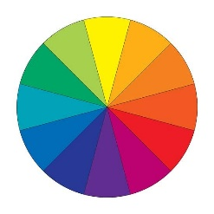

Warm colours are red and include oranges, yellows, and brown.

Cold colours are blue and include greens and violets.

Black, white and grey are neutral colours.