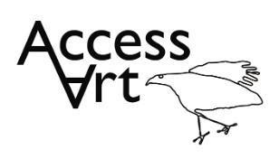
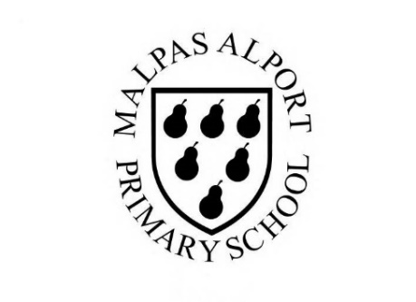
https://www.accessart.org.uk/typography-and-maps/

Autumn Term Year 5/6 Cycle A Typography and Maps |  | Topic: Drawing and Sketchbooks |  | Cultural Capital: Watch art videos online to increase access to places you are unable to visit. Visit local galleries, museums, crafts groups, artists.
National Curriculum Objectives (KS2):
Pupils should be taught to develop their techniques, including their control and their use of materials, with creativity, experimentation and an increasing awareness of different kinds of art, craft and design.
Pupils should be taught:
- to create sketch books to record their observations and use them to review and revisit ideas
- to improve their mastery of art and design techniques, including drawing, painting and sculpture with a range of materials [for example, pencil, charcoal, paint, clay]
- to know about great artists, architects and designers in history.
Enquiry Question: How can we use drawing and graphics skills to create typography? How can we use typography skills to create pictorial maps?
Previous Learning:
Yr 3 & 4:
- Developed dexterity skills including mark making. Developed making skills. Explored intention and how artists experience is brought to evidence in the art made.
Future Learning (Yr 6):
- Continue to explore relationship of 2d to 3d. Develop ideas about identity, purpose and intention. Develop dexterity skills.
Lesson Theme | Retrieval | Learning Target: | Activity | Success Criteria | Vocabulary | Key Concepts
Lesson 1: Introduction to Typography | What is ‘typography’? | To understand how typography can be used creatively to communicate thoughts and ideas. | Pupils will become familiar with the term ‘typography’. They will be introduced to designers who work with type to communicate thoughts and ideas visually. Pupils will create their own letters from cut up basic shapes in a playful way to think about the form of letters. They will work in their sketchbooks to consider what they like and what they might develop further. | I have understood that typography is the visual art of creating and arranging letters and words on a page to help communicate ideas or emotions.  I have seen how other artists work with typography and have been able to share my thoughts on their work.  I have explored how I can create letters in a playful way using cutting and collage. I can reflect upon what I like and the letters I have made. | Typography, Lettering, Graphics, Design,  Communicate, Emotions, Purpose, Intention,  Playful, Exploratory, | That when designers work with fonts and layout it is called typography.  That we can use the way words look to help us communicate ideas and emotions.
Lesson 2: Design Type | How can I make my own typography using my interests? | To create my own typeface inspired by my own interests. | Pupils will create their own letters of a typeface using their intuition. Working in large scale they will explore as many variations of letters as they can think of, developing them into a whole word or a phrase. | I have drawn my own letters using pen and pencil inspired by objects I have chosen around me, and I can reflect upon why my letters have a meaning to me.  I have used my sketchbook for reference, collecting, testing, and reflecting. |  | That we can create our own typography and combine it with other visual elements to make artwork about chosen themes.
Lesson 3: Strong Drawings | How can I make graphic powerful drawings? | To make my drawings strong and powerful. | Pupils will work over maps / newspaper / pre-printed paper to create strong bold drawings that stand out over the background. Pupils will build confidence in their strong mark-making skills. | I can make my drawings appear visually stronger by working over maps or newspaper to make my marks stronger. | Visual Impact,
Lesson 4 & 5: Messages in Maps | How can I create a visual map? | To apply my new typography skills and my powerful drawings skills to make a visual map. | Pupils will be introduced to artists who create maps. They will discover that maps can reveal things about the artist who made them, provide comments about a culture, place, and time, or be based in imagination. They will respond to the work in class discussion and in their sketchbooks. Pupils will develop ideas from the typography activity in week 2, to build visual text for map making. They will link to their own identity through their maps with typography, references, thoughts, ideas, and associations. They will do this in both 2D and 3D. | I have seen how some artists use their typography skills and drawing skills to make maps which are personal to them. I have been able to reflect upon what I think their maps mean, what I like about them, and what interest me.  I can use mark making, cutting and collage to create my own visual map, using symbols, drawing elements and typography to express themes which are important to me. | Pictorial Maps, Identity, Symbols,
Lesson 6: Share, Reflect, Discuss | How can I reflect on my work? | To display the work made through the half term and reflect on the outcomes. | Pupils will display their work in a clear space and reflect on the half term, sharing what they like, what they would like to try again, the creative journey, and the skills learnt through peer discussion. | I have shared my work with the class, reflected upon what was successful and been able to give useful feedback on the work of my peers. | Present, Share, Reflect, Respond, Articulate, Feedback, Crit, Similarities, Differences, | That when we reflect on our own work and the work of others, we think about what we are good at and what we might do differently next time.
Learning Outside of the Classroom?
- Find examples of typography in the media, online, in books, and in the environment. Base pictorial maps on local environments.
Cross Curricular Opportunity:
- Geography: Trade links, digital mapping, ordinance survey maps, detailed sketching of maps.
- History: Create maps inspired by your chosen ancient civilisation topic e.g. an Anglo Saxon settlement or village.
- Maths: Pictorial representations, 2D / 3D shapes.
- PSHE: Collaboration, Peer Discussion.
Impact/Assessment
- Monitored by sketchbook work, one to one or small group conversation, whole class discussion, final outcome.
- Identify any personal challenges preventing meeting “I Can” statements
- Identify any weaknesses common to many in class which might help identify areas you need to focus on again as a teacher.
- Identify areas of particular strength which might benefit from being developed.
- No grades to be applied, no learning objectives in the sketchbooks, no teacher marking in sketchbooks.

