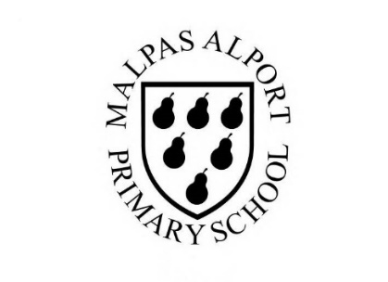
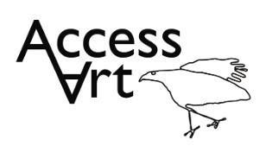
https://www.accessart.org.uk/making-monotypes/

Spring Term Year 5/6 Cycle A  Making Monotypes |  | Topic: Print, Colour, Collage |  | Cultural Capital: Watch art videos online to increase access to places you are unable to visit. Visit local galleries, museums, crafts groups, artists.
National Curriculum Objectives (KS2):
Pupils should be taught to develop their techniques, including their control and their use of materials, with creativity, experimentation and an increasing awareness of different kinds of art, craft and design.
Pupils should be taught:
- to create sketch books to record their observations and use them to review and revisit ideas
- to improve their mastery of art and design techniques, including drawing, painting and sculpture with a range of materials [for example, pencil, charcoal, paint, clay]
- to know about great artists, architects and designers in history.
Enquiry Question: How can we use mono type to make a creative response to poetry or prose?
Previous Learning:
Years 3 & 4:
- Introduced idea that we can make a creative response to artwork, including artwork in other genres, e.g. literature. Introduced mono print and developed drawing skills. Explored colour mixing
Future Learning (Yr 6):
- Develop skills in making a creative response to another stimulus. Develop mark making and colour skills and experience of working in mixed media work. Develop articulation skills.
Lesson Theme | Retrieval | Learning Target: | Activity | Success Criteria | Vocabulary | Key Concepts
Lesson 1: | What is a monotype print? | To identify monotype prints made by artists. | Pupils will become familiar with the term ‘monotype’. They will explore the work of Kevork Mourad to find out about the concepts and processes that he uses. Pupils will respond by making visual notes to collect information in their sketchbook. | I have understood what a Monotype is and can see how artists use monotypes in their work. I have been able to share my response to their work. | Mono type, Artists Book, Installation | That Monotype is a process where we make images by transferring ink from one surface to another to make a single print.
Lesson 2: Mark Making | How might I expand my mark making vocabulary? | To open my mark making vocabulary by varying the tool, hold, pressure, speed, and intention. | Pupils will be reminded of the vast array of marks available to them through looking at others artist’s work. They will work in sketchbooks to create a lexicon of marks made by varying the tool, hold, pressure, speed, and intention of the way the mark is made. | I can study drawings made by other artists and identify marks they have used in their drawings. I can use my sketchbook to collection of marks for me to use later.
Lesson 3 & 4 & 5: Print, Paint and Collage | How might I combine print, paint and collage? | To respond to a poem in the form of a zine made from painted, collaged, and printed elements. | Pupils will explore how they can use monotype to create their own personal zines. They will respond to poetry by considering colour, line, shape, and words. They will use these components to capture the mood of the poem. Pupils will work in sketchbooks to generate ideas, explore, develop, and reflect. They will use the mark making skills from week 2 to create exciting monotypes, combining process, paintings, and collage. | I can listen to a piece of poetry and think about how the piece evokes colours, lines, shapes, and words in my head. I can use these things to create imagery which captures the mood of the piece of poetry.  I can use my sketchbook to explore ideas.  I can use my mark making skills to create monotypes, combining the process with painting and collage. | Poetry, Evoke, Response, Translate,  Mood, Sense,  Layer, Combine, Multi Media | That we can use the ‘distance’ that monotype gives us between mark making and outcome to make images with texture and a sense of history/process.  That we can combine monotype with other disciplines such as painting and collage.  That we can make art by expressing our own personal response to literature or film.
Lesson 6: Share, Reflect, Discuss | How can I reflect on my work? | To display the work made through the half term and reflect on the outcomes. | Pupils will display their work in a clear space and reflect on the half term, sharing what they like, what they would like to try again, the creative journey, and the skills learnt through peer discussion. | I can share my thinking and outcomes with my classmates. I can listen to their views and respond.  I can share my response to the artwork made by my classmates.  I can photograph my work, thinking about lighting, focus, and composition. | Present, Share, Reflect, Respond, Articulate, Feedback, Crit, Similarities, Differences, | That when we reflect on our own work and the work of others, we think about what we are good at and what we might do differently next time.
Learning Outside of the Classroom?
- Watch or listen to performances in theatre or arts centres to inspire a creative response.
Cross Curricular Opportunity:
- Curriculum Links
- English: Use a poem or story to inspire making your own monotype books.
- History: Make a zine about your theme or focus.
- PSHE: Supports Responsibility to the planet, Collaboration, Peer Discussion.
Impact/Assessment
- Monitored by sketchbook work, one to one or small group conversation, whole class discussion, final outcome.
- Identify any personal challenges preventing meeting “I Can” statements
- Identify any weaknesses common to many in class which might help identify areas you need to focus on again as a teacher.
- Identify areas of particular strength which might benefit from being developed.
- No grades to be applied, no learning objectives in the sketchbooks, no teacher marking in sketchbooks.

