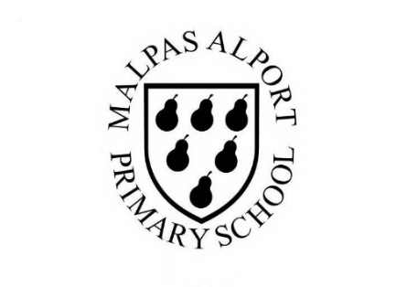
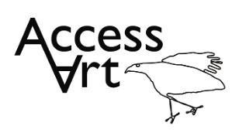
https://www.accessart.org.uk/telling-stories-through-making/

Summer Term Year 3/4 Cycle A Telling Stories Through Drawing and Making |  | Topic: Working in 3 Dimensions |  | Cultural Capital: Watch art videos online to increase access to places you are unable to visit. Visit local galleries, museums, crafts groups, artists.
National Curriculum Objectives (KS2):
Pupils should be taught to develop their techniques, including their control and their use of materials, with creativity, experimentation and an increasing awareness of different kinds of art, craft and design.
Pupils should be taught:
- to create sketch books to record their observations and use them to review and revisit ideas
- to improve their mastery of art and design techniques, including drawing, painting and sculpture with a range of materials [for example, pencil, charcoal, paint, clay]
- to know about great artists, architects and designers in history.
Enquiry Question: How can we create 3 dimensional characters inspired by characters in film and fiction?
Previous Learning:
KS1:
- Introduced idea that sculptures can have “characters” and “personality” created by form, texture, and colour. Introduced basic making skills through Design Through Making, including basic experience putting materials together (and using tools) into one constructed piece. Understanding that we can react (as humans) to what we all create.
Future Learning (KS2):
- Develop idea that we can create our own art, inspired by art made by other people. Develop making skills, including knowledge about material choice, method, construction etc and growing experience to understand how to push a piece of sculpture based upon original intention and outcome.
Lesson Theme | Retrieval | Learning Target: | Activity | Success Criteria | Vocabulary | Concepts
Lesson 1: artists and sketchbooks | How art artists inspired by other artforms? | To understand that artists use sketchbooks to respond to other creative artforms. | Pupils will look at the work of artists Inbal Leitner and Rosie Hurley to see how they use their sketchbooks to develop characters and refine ideas. They will respond by filling a couple of pages in their sketchbooks with visual notes about what they are thinking and seeing. | I have seen how artists are inspired by other artists often working in other artforms.  I have understood how artists sometimes use sketchbooks to understand and explore their own response to an artist’s work.  I can use my sketchbook to explore my response, making visual notes, jotting down ideas, and testing ideas. | Sketchbooks, Brainstorm, Explore, Experiment, Test, Try Out, | That we can take inspiration from other artforms such as film and literature and make drawings in response.
Lesson 2: Drawing | How can I use exaggeration as a tool to convey the intention of my drawing? | To use exaggeration as a tool to convey the intention of my drawings. | Pupils will try three simple exercises to help them draw from life and explore how we might use exaggeration as a tool to help us convey the intention of our drawing. Pupils will use line and shape and will also create a watercolour wash painting to consolidate all that they have learnt in the session. |  | Line, Shape, Wash, Layer, Pen, Watercolour, Exaggerate, Gesture, | That through making work in another medium we can make work our own, re-interpreting and re-inventing.  That we can explore character, narrative and context to create drawings.
Lesson 3 & 4 & 5: Make | How can I respond to literature/poetry in the form of sculpture? | To make a 3d sculpture in response to literature/poetry. | Pupils will translate text into imagery using shape and line. They will use their sketchbooks to respond to the original stimulus before developing a sculptural character, Pupils will, re-interpret, and re-invent the character whilst exploring the qualities of different materials. They will explore character, narrative, and context to create their sculptures showing consideration for form, texture, material, construction, and colour. | I can make a sculpture using materials to model or construct which is inspired by a character in a book to film. | Sculpture, Armature, Structure, Cover, Modroc, Clay, Construct, Model, Character, Personality, | That we can explore character, narrative, and context and create sculptures which will convey these qualities though their form, texture, material, construction, and colour
Lesson 6: Share, Reflect, Discuss | How can I reflect on my work? | To display the work made through the half term and reflect on the outcomes. | Pupils will display their work in a clear space and reflect on the half term, sharing what they like and what they would like to try again through peer discussion. | I can reflect and share how the way I made my sculpture helps capture feelings about the original character.  I can enjoy looking at the sculptures made by my classmates and see ways in which they are different and similar to each other and to the original character.  I can share my feedback about my classmate’s work. | Present, Share, Reflect, Respond, Feedback,  Photograph, Lighting, Composition, Focus, Intention, | That when we reflect on our own work and the work of others, we think about what we are good at and what we might do differently next time.
Learning Outside of the Classroom?
- Visit local theatre to experience how others create versions of other people’ s characters.
Cross Curricular Opportunity:
- English: Link to “character” books such as Roald Dahl’s Esio Trot, Dirty Beasts, The Minpins or James and the Giant Peach to inspire making.
- Science: Materials, animals, micro habitats.
- Maths: 2D/3D shapes, measuring, weight.
- PSHE: Responsibility to the planet, collaboration, peer discussion.
Impact/Assessment
- Monitored by sketchbook work, one to one or small group conversation, whole class discussion, final outcome.
- Identify any personal challenges preventing meeting “I Can” statements
- Identify any weaknesses common to many in class which might help identify areas you need to focus on again as a teacher.
- Identify areas of particular strength which might benefit from being developed.
- No grades to be applied, no learning objectives in the sketchbooks, no teacher marking in sketchbooks.

