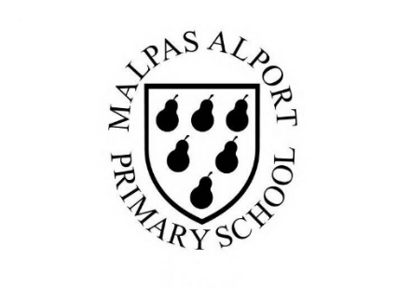
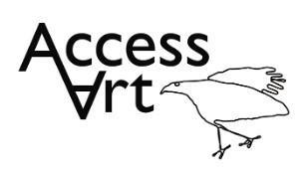
https://www.accessart.org.uk/storytelling-through-drawing/
Autumn Term Year 3/4 Cycle B Storytelling through Drawing |  | Topic: Drawing and Sketchbooks |  | Cultural Capital: Watch art videos online to increase access to places you are unable to visit. Visit local galleries, museums, crafts groups, artists.
National Curriculum Objectives (KS2):
Pupils should be taught to develop their techniques, including their control and their use of materials, with creativity, experimentation and an increasing awareness of different kinds of art, craft and design.
Pupils should be taught:
- to create sketch books to record their observations and use them to review and revisit ideas
- to improve their mastery of art and design techniques, including drawing, painting and sculpture with a range of materials [for example, pencil, charcoal, paint, clay]
- to know about great artists, architects and designers in history.

Enquiry Question: How can we create visual narratives inspired by poetry or prose?
Previous Learning:
KS1
- Introduced idea that we can interpret other people’s prose and make work in response. Introduced basic mark making and media exploration.
Future Learning (KS2):
- Continue to develop interpretation skills and use more sophisticated ideas and technical skills to make own creative response. Continue to explore how different artforms such as drama, music, literature can inspire artwork.
Lesson Theme | Retrieval | Learning Target: | Activity | Success Criteria | Vocabulary | Key Concepts
Lesson 1: Introduce artists | How do artists use a sequence of imagery to tell a story? | To explore the work of artists who tell stories through imagery. | Pupils will explore the work of two artists who create illustrations that tell stories. Pupils will respond to their work through verbal discussion in class as well as by collecting and consolidating information with visual notes. | I have explored the work of artists who tell stories through imagery.  I can respond to the work of illustrators and/or graphic novelists “reading” the visual images and sharing my thoughts.  I can work in a sketchbook to record my ideas and thoughts generated by looking at other artist’s work. | Illustration, Inspiration, Interpretation, Original Source, Respond, Response  Graphic Novel, Illustrator, | That we can tell stories through drawing.
Lesson 2: Drawing warm up | How can I create an image that tells a story? | To use toys, poetry, and my own text to create a richly illustrated narrative in a single drawing. | Pupils will use toys, poetry, and their own text to create richly illustrated narratives contained within a single drawing. Pupils will juxtapose objects to create their still life scenes from which they will work. Pupils will explore the materials charcoal, chalk, compressed charcoal pencil, and eraser to make their drawings. | I can use a sketchbook to generate ideas about how I might respond to a piece of poetry or prose.  I can use line, shape, and colour using a variety of materials to text my ideas. | Poetry, Prose, Stage, Arrange  Line, Quality of line, Line Weight, Mark Making, Medium, Graphite, Ink, Pen, Quill, Brush, Watercolour, Watersoluble, | That we can use text within our drawings to add meaning.
Lesson 3 & 4 & 5: Illustrate a narrative | How can I make a sequence of images that describe a narrative? | To create a finished piece which contains sequenced images to describe a narrative. | Pupils will explore how they can build and share a story through a series of images. They will work from evocative literature or poetry to create either a concertina or a poetry comic. Pupils will have lots of opportunity to explore different materials such as charcoal, graphite, ink, or pastel. Pupils will use sketchbooks to develop ideas throughout. | I can use line, shape, and colour using a variety of materials to text my ideas.  I can think about how I might use composition, sequencing, mark making and some text in my drawings.  I can create a finished piece which contains sequenced images to describe a narrative. | Composition, Sequencing, Visual Literacy, Narrative | That we can sequence drawings to help viewers respond to our story.  That we can use line, shape, colour, and composition to develop evocative and characterful imagery.
Lesson 6: Share, reflect, discuss | How can I reflect on my work? | To display the work made through the half term and reflect on the outcomes. | Pupils will display their work in a clear space and reflect on the half term, sharing what they like and what they would like to try again through peer discussion. | I can share my work with others and talk about my journey and outcome. I can listen to their feedback and take it on board.  I can appreciate the work of my classmates and think about the similarities and differences between our work. I can share my feedback on their work. | Present, Share, Reflect, Respond, Articulate, Feedback, Crit, Similarities, Differences, | That when we reflect on our own work and the work of others, we think about what we are good at and what we might do differently next time.
Learning Outside of the Classroom?

Cross Curricular Opportunity:
- English: Use The Jabberwocky by Lewis Carol as inspiration for this pathway, or choose another story or graphic novel of your choice.
- History: Create your own sequenced story inspired by an event in history ie from The Anglo Saxon, The Viking, Ancient Greeks, Ancient Egyptian or The Roman eras.
- Science: Use language to support concepts around light and shadow, and how this can be explored on paper through drawing.
- PSHE: Supports Collaboration, Peer Discussion.
Impact/Assessment
- Monitored by sketchbook work, one to one or small group conversation, whole class discussion, final outcome.
- Identify any personal challenges preventing meeting “I Can” statements
- Identify any weaknesses common to many in class which might help identify areas you need to focus on again as a teacher.
- Identify areas of particular strength which might benefit from being developed.
- No grades to be applied, no learning objectives in the sketchbooks, no teacher marking in sketchbooks.

