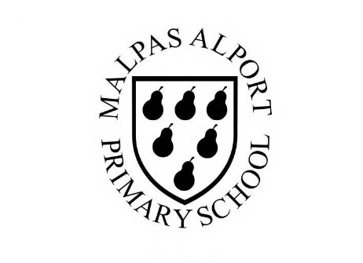
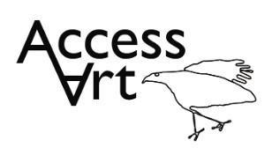
https://www.accessart.org.uk/spirals/
Autumn Term Year 1/2 Cycle A :  Spirals |  | Topic: Drawing & Sketchbooks |  | Cultural Capital: Watch art videos online to increase access to places you are unable to visit. Visit local galleries, museums, crafts groups, artists.
National Curriculum Objectives (KS1):
- to use drawing, painting and sculpture to develop and share their ideas, experiences and imagination
- to develop a wide range of art and design techniques in using colour, pattern, texture, line, shape, form and space
- know about the work of a range of artists, craft makers and designers, describing the differences and similarities between different practices and disciplines, and making links to their own work.
Enquiry Question: How can we use our whole bodies to make drawings?
Previous Learning:
Reception:
Future Learning (KS2):
- Appreciation that drawing is a physical and mental activity. Continue to develop making gestural drawings using whole body.
Lesson Theme | Retrieval | Learning Target: | Activity | Success Criteria | Vocabulary | Key Concepts
Lesson 1: Drawing from imagination | How can we use our bodies to make drawings? | To create drawings using your wrists elbow, shoulders, hips. | Pupils will become familiar with creating drawings using their whole body, whilst experiencing a range of drawing materials. Pupils will discover an artist and will demonstrate their understanding of the artist’s work by responding through a making challenge and peer discussion. | I can draw form my finger tips, my wrist, my elbow, my shoulder, my body.  I can make different marks with different drawing tools. I have seen the different marks I can make with a soft pencil, a graphite stick and a handwriting pen.  I have seen the work of an artist and listened to how the artist made the work. I can share how I feel about the work. | Spiral, Movement, Pressure, Motion, Line, Continuous Line, Small, Slow, Larger, Faster, Careful  Hand, Wrist, Elbow, Shoulder  Graphite, Chalk, Pen  Drawing Surface (Paper, Ground | Drawing is a physical and emotional activity. That when we draw, we can move our whole body.  That we can control the lines we make by being aware of how we hold a drawing tool, how much pressure we apply, and how fast or slow we move.
Lesson 2: Developing drawings | What kinds of marks can we make with chalk and oil pastels? | To create a “snail drawing’” on white cartridge paper or black sugar paper using chalk and oil pastels. | Pupils will consolidate their understanding of how they can make spiral drawings using their whole bodies by making “snail drawings”. Pupils will push exploration of different qualities of line, colour blending, and mark making using chalk and oil pastels. | I can make choices about which colours I’d like to use in my drawings.  I can make different marks with different drawing tools.  I have seen the different marks I can make with oil pastels and chalk. | As above plus:  Oil Pastel, Dark, Light, Blending  Mark Making  Colour, Pattern | That we can control the lines we make by being aware of how we hold a drawing tool, how much pressure we apply, and how fast or slow we move.  That we can use colour to help our drawings engage others.  That we can draw from imagination.
Lesson 3: Sketchbooks | What is a sketchbook and what can we use it for? | To personalise or make our own sketchbooks. | Pupils will become familiar with what a sketchbook can be used for. They will make or personalise their own sketchbooks, demonstrating that they have ownership of their sketchbook and understand that it is a platform for personal creative risk taking. | I can make or personalise a sketchbook and feel that it belongs to me. | As above plus:  Sketchbook, Pages, Elastic Band, Measure, Size, Cover, “Spaces and Places” | That we understand what a sketchbook is.  That we can use a sketchbook for personal creative exploration.
Lesson 4: Observation and experimental mark making | How can I apply mark making to observational drawing? | To apply our spiral explorations to  observational drawings of shells. | Pupils will become familiar with the idea that they can make drawings through observation. Pupils will show an understanding of what a continuous line drawing is and have had the opportunity to experiment with scale, line and materials. | I can draw from observation for a few minutes at a time.  I can make a drawing using continuous line for a minute or two.  I can make different marks with different materials. | As above plus:  Observation, Careful Looking, Object, Drawing, (Water Soluble), Colour, | That we can draw from observation.  That we can experiment with mark making through exercises such as continuous line drawing.  That we can create drawings in our sketchbooks.
Lesson 5:
Lesson 6: Share, reflect, discuss | How can I reflect on my artwork? | To display the work made through the half term and talk about outcomes. | Pupils will reflect on their drawings over the half term, sharing what they like and what they would like to try again through peer discussion. | I can talk about what I like in my drawings, and what I’d like to try again.  I can listen to other pupils discussing their work.  I can tell other pupils what I like about their work. | Reflect, Discuss, Share, Think | That we can talk respectfully about our own work and the work of others in a peer discussion.  That we can display the work made over the half term.
Learning Outside of the Classroom?
- Collecting / Finding Materials to Draw.

Cross Curricular Opportunity

Science: Uses language to support understanding of concepts of growth, human body and natural forms.
Maths: Explores pattern, symmetry.
PSHE: Peer discussion, collaboration
Impact/Assessment
- Monitored by sketchbook work, one to one or small group conversation, whole class discussion, final outcome.
- Identify any personal challenges preventing meeting “I Can” statements
- Identify any weaknesses common to many in class which might help identify areas you need to focus on again as a teacher.
- Identify areas of particular strength which might benefit from being developed.
- No grades to be applied, no learning objectives in the sketchbooks, no teacher marking in sketchbooks.
- Collect images of both journey and outcome. Remember intention is an important indicator and may not yet be reflected in outcomes.

