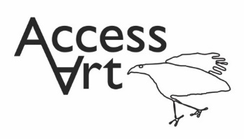
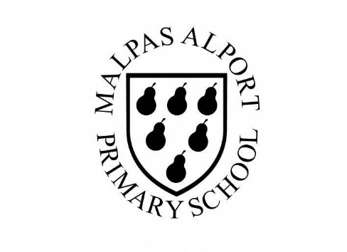
https://www.accessart.org.uk/stick-transformation-project/

Summer Term Year 1/2 Cycle B :  Stick Transformation Project |  | Topic: Working in 3 Dimensions |  | Cultural Capital: Watch art videos online to increase access to places you are unable to visit. Visit local galleries, museums, crafts groups, artists.
National Curriculum Objectives (KS1):
- to use a range of materials creatively to design and make products
- to use drawing, painting and sculpture to develop and share their ideas, experiences and imagination
- to develop a wide range of art and design techniques in using colour, pattern, texture, line, shape, form and space
- to know about the work of a range of artists, craft makers and designers, describing the differences and similarities between different practices and disciplines, and making links to their own work.
Enquiry Question: How can we transform an object and turn it into sculpture, using our imagination.
Previous Learning:
Reception:
- Introduced idea that artists transform materials and objects to create something new.
Future Learning (KS2):
- Continue to develop skills which enable us to re-see the world and transform materials into something new. Continue to develop dexterity skills and articulation skills. Continue to explore ideas about scale and context. Continue to develop skills which enable us to appreciate structure and balance. Build understanding about how we can create narratives around the objects we find/make to help us understand them and share with others.
Lesson Theme | Retrieval | Learning Target: | Activity | Success Criteria | Vocabulary | Key Concepts
Lesson 1: Making Challenge | How can I be inventive with materials? | To use my imagination to play and explore using materials. | Pupils will think creatively and laterally, and practise dexterity skills by using a range of materials to build roots and shoots from ‘seeds’. Pupils will learn to manipulate materials by twisting, tearing, folding and bending materials to form structures. They will take photos of their sculptures to put in their sketchbooks to reflect on. | I can fasten materials together to construct my sculpture. | Design Through Making, Play, Explore, Experiment,  Fasten, Construct, Respond, Think  Form, Personality, Character, Material, Object, Sculpture | That making art can be playful and fun.
Lesson 2 & 3 & 4 & 5: Make | How can I reimagine a familiar object? | To use my imagination to reinvent the stick. | Pupils will transform sticks to make either worry dolls, a tree house or masks out of sticks. In each of these activities they will continue developing dexterity skills such as cutting with simple tools and fastening materials together. They will be introduced to artists or source material which will inspire and inform their idea generation. Pupils will respond to stimulus and will generate ideas in sketchbooks. They will test ideas alongside this to transform a variety of objects showing a consideration for form and colour. | I can take a familiar object like a stick and use my imagination to think about what it might become.  I can use my sketchbooks to generate and test ideas.  I can use a variety of materials to transform my object, thinking about form and colour.  I can cut materials with simple tolls and fasten materials together to construct my sculpture. | Find, Imagine, Select, Discard, Edit,  Transform, Create  Line, Shape, Form, Angle, Scale, Structure, Balance, Sculpture, Colour, materials, Texture  Test, Explore, Add, | That artists use their creativity to look at the world in new ways and use their hands to transform materials into new things.  That making art can be playful and fun. That we can create things for other people to use and enjoy.  That we can use our imagination to help us shape the world.
Lesson 6: | How can I reflect on the work created throughout the half term? | To display the work made through the half term and reflect on the outcomes. | Pupils will display their work in a clear space and reflect on the half term, sharing what they like and what they would like to try again through peer discussion. | I can share my sketchbook and sculpture with the class and talk about how I made it and what I liked. I can listen to my classmate’s feedback about my work.  I can listen to my classmates talk about their own artwork and I can share my thoughts about their work. | Present, Share, Reflect, Respond, Feedback  Photograph, Film, Document, Lighting, Focus, Angle, Composition, Record | That when we reflect on our own work and the work of others, we are considering what we are good at and what we might do differently next time.
Learning Outside of the Classroom?
- Explore local environment to collect materials for the projects.
Cross Curricular Opportunity:
- English: Link to Julia Donaldson’s Stick Man
- PSHE: Collaboration, Peer Discussion, Ethnic Identity,
Impact/Assessment
- Monitored by sketchbook work, one to one or small group conversation, whole class discussion, final outcome.
- Identify any personal challenges preventing meeting “I Can” statements
- Identify any weaknesses common to many in class which might help identify areas you need to focus on again as a teacher.
- Identify areas of particular strength which might benefit from being developed.
- No grades to be applied, no learning objectives in the sketchbooks, no teacher marking in sketchbooks.

