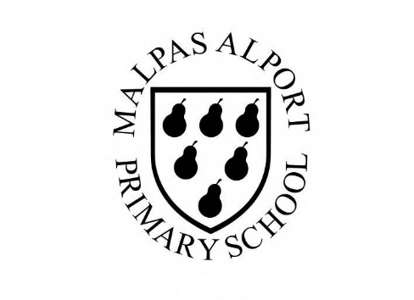
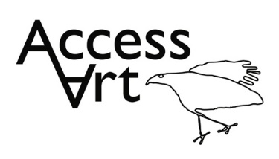
https://www.accessart.org.uk/expressive-painting/

Spring Term Year 1/2 Cycle B  Expressive painting |  | Topic: Paint, Texture, Colour |  | Cultural Capital: Watch art videos online to increase access to places you are unable to visit. Visit local galleries, museums, crafts groups, artists.
National Curriculum Objectives (KS1):
- to use a range of materials creatively to design and make products
- to use drawing, painting and sculpture to develop and share their ideas, experiences and imagination
- to develop a wide range of art and design techniques in using colour, pattern, texture, line, shape, form and space
- to know about the work of a range of artists, craft makers and designers, describing the differences and similarities between different practices and disciplines, and making links to their own work.

Enquiry Question: How can we explore colour using a variety of mark-making tools?
Previous Learning:
Reception:
- Explored the properties of watercolour and discovered how we can work WITH the characteristics of the medium to make art. Basic colour awareness and mixing.
Future Learning (KS2):
- Continue to understand and explore that there are many different ways to paint – none of which are “better” than others. Continue to develop experience and understanding of paint as a medium, and of HOW we apply paint and the INTENTION behind our action affect outcome. Continue to develop visual literacy and mark making skills. Continue to build experience of colour mixing, hues and tints. Continue to develop understanding of how others respond to art, bringing their own unique perspective.
Lesson Theme | Retrieval | Learning Target: | Activity | Success Criteria | Vocabulary | Key Concepts
Lesson 1: Introduce artists | What might an expressive painting look like? | To identify and respond verbally and visually to an expressive painting. | Pupils will become familiar with the term ‘expressionism’. They will be introduced to two artists who use colour and mark making to make art. Pupils will take part in discussion, responding to artists work verbally and visually in sketchbooks and peer conversation. | I have seen how contemporary artists sometimes paint in expressive, loose ways to create paintings full of life and colour.  I can start to share my response to the work of other artists.  I can use my sketchbooks to record colour and brush marks inspired by other artists. | Gesture, Gestural, Mark making, Loose, Evocative, Emotion,  Intention, Exploration, Reaction, Response  Personal, Imagination,  Energy, Impression, Colour, Life, Shape, Form, Texture, Line | That artists sometimes use loose, gestural brush marks to create expressive painting.  Expressive painting can be representational or more abstract.  Artists sometimes use colour intuitively and in an exploratory manner.
Lesson 2: Expressive painting and colour mixing | How can I make an expressive painting? | To use both colour mixing and mark making to make an expressive painting. | Pupils will use various home-made tools to apply paint in abstract patterns. They will continue to develop their knowledge of primary and secondary colours through expressive mark making, connecting colour and texture. Pupils will then consolidate what they have learnt by recording and reflecting in sketchbooks. | I can recognise primary colours and mix secondary colours. I can experiment with hues by changing the amount of primary colour I add.  I can use various home-made tools to apply paint in abstract patterns. I can be inventive. | Primary Colours (Red, Yellow, Blue), Secondary Colours (Green, Purple, Orange), Tints, Hues,  Medium, Surface, Texture, Impasto  Brush, Mark making Tools, Palette Knife, Home-Made Tools,  Abstract, Explore, Invent, Discover, Reflect, | That we can enjoy and respond to the way paint and colour exist on the page.
Lesson 3: Brushwork | How do old masters use brushwork in expressive paintings? | To identify different brushwork used by old masters Van Gogh and Cezanne. | Pupils will explore the brushwork of two old masters. They will focus in on details of paintings to understand how they built the work. Pupils will respond through class discussion and creating visual notes in their sketchbooks. Pupils will record similar brush marks that they see in paintings and capture the colour that stand out to them. | I have seen how old masters painted in expressive, loose ways to create paintings full of life and colour.  I can start to share my response to the work of other artists. | Focus, Detail, Dissect, Imagine, Intention | Expressive paintings can be representational or more abstract.  That artists sometimes use loose, gestural brush marks to create expressive painting.  Artists use impasto and sgraffito to give texture to the painting.
Lesson 4 & 5: Gestural mark making | How can I make an expressive painting based on a still life composition? | To utilise the skills I have picked up relating to mark making, composition and colour mixing and apply it to my own still life painting. | Pupils will arrange their own still life scene which they will go on to make continuous line drawings of. They will expand their journey by introducing colour and form by tearing and arranging coloured paper in their composition. Pupils will go on to use acrylic paint to create gestural paintings of their still life scene, pitting into practice all that they have experienced during the half term. | I can make a loose drawing from a still life.  I can see colours and shapes in my still life painting.  I can use gestural mark making with paint and capture the colours and shapes in the still life to make an expressive painting. | Still Life,  Line, Rhythm, Gesture, Mark  Composition, Positive shapes, Negative shapes  Balance, | That we can enjoy and respond to the way paint and colour exist on the page.
Lesson 6: Reflect, share, and discuss | How can I reflect on the work created throughout the half term? | To display the work made through the half term and reflect on the outcomes. | Pupils will display their work in a clear space and reflect on the half term, sharing what they like and what they would like to try again through peer discussion. | I can share my experiments and final piece with others and share what I liked and what went well.  I can enjoy the work of my classmates and I can see how all the work is different. I can share my response to some of their work. | Present, Share, Reflect, Discuss, Feedback, | That when we reflect on our own work and the work of others, we are considering what we are good at and what we might do differently next time.
Learning Outside of the Classroom?
- Opportunities to paint from life outside.
Cross Curricular Opportunity:
- Geography: After looking at the expressive landscapes by Van Gogh and Cezanne, be inspired by your local landscape (United Kingdom) and use gestural brush strokes to paint a scene you know or see, or explore weather, habitat, river or sea.
Impact/Assessment
- Monitored by sketchbook work, one to one or small group conversation, whole class discussion, final outcome.
- Identify any personal challenges preventing meeting “I Can” statements
- Identify any weaknesses common to many in class which might help identify areas you need to focus on again as a teacher.
- Identify areas of particular strength which might benefit from being developed.
- No grades to be applied, no learning objectives in the sketchbooks, no teacher marking in sketchbooks.

