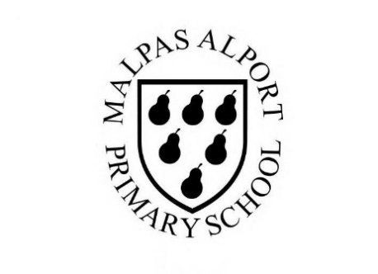
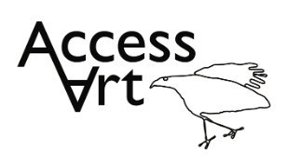
https://www.accessart.org.uk/simple-printmaking/

Spring Term Year 1/2 Cycle A :  Simple Printmaking |  | Topic: Print, Colour, Collage |  | Cultural Capital: Watch art videos online to increase access to places you are unable to visit. Visit local galleries, museums, crafts groups, artists.
National Curriculum Objectives (KS1):
- to use a range of materials creatively to design and make products
- to use drawing, painting and sculpture to develop and share their ideas, experiences and imagination
- to develop a wide range of art and design techniques in using colour, pattern, texture, line, shape, form and space
- to know about the work of a range of artists, craft makers and designers, describing the differences and similarities between different practices and disciplines, and making links to their own work.

Enquiry Question: How can we make prints using the things we find around us?
Previous Learning:
Reception:

Future Learning (KS2):
- Developing use of line and shape in making more sophisticated prints including monoprints.
Lesson Theme | Retrieval | Learning Target: | Activity | Success Criteria | Vocabulary | Key Concepts
Lesson 1: Printing with your body | What is a print? | To identify how we can use our hands and feet to create prints of patterns. | Pupils will use their hands and feet to explore printing patterns using their bodies. Pupils will be introduced to primary paint colours and will demonstrate an understanding of how they can create a ‘print’ using controlled pressure and paint amounts. Pupils may have time to experiment with line, shape and colour to create drawings over the top of their prints. | I can make simple prints using my hands and feet.  I can use colour, shape and line to make my prints interesting. | Print, Press, Pressure, Paint  Primary colours: Red, Yellow, Blue  Shape, Line, Arrangement | That we can use our bodies as a “plate” from which to “print”.  That we can work into prints by overlaying line, shape and colour to experiment with composition.
Lesson 2: Making Rubbings | How can I make a ‘rubbing’? | To identify how you can use textured objects to make prints. | Pupils will collect textured objects which they will take rubbings from, using materials such as wax crayons or pencil crayons. Pupils will work in sketchbooks or on large sheets to create compositions with their rubbings. | I can explore my environment and take rubbings of textures I find.  I can use my sketchbook to collect my prints and test ideas. | As above plus:  Rubbing, Texture,  Wax crayon, Pencil Crayon, Cut, Collage, Stick, Arrange  Explore, Try, Test, Reflect | That we can explore line and texture to explore pattern, sequence, symmetry, and intention.
Lesson 3 & 4 & 5: Explore and develop simple print making | How can I make a relief print? | To identify how you can make a relief print using a ‘plate’. | Pupils will be introduced to ‘relief printing’. They will demonstrate their understanding of the relationship between a plate and a print through making either impressions in plasticine or creating a deep recess in foam board. Pupils will demonstrate their understanding of using controlled pressure and paint amounts to create a print. Pupils will have the opportunity to demonstrate an understanding of ‘repeat pattern/repetition’ using collage. | I can push objects I find into plasticine and make prints.  I can cut shapes out of foam board and stick them on a block to make a plate. I can print from the plate.  I can draw into the surface pf foam board and print form the plate.  I can create a repeat print.  I can use my sketchbook to collect my prints and test ideas. | As above plus:  Artwork, Artist: Printmaker  Relief print, Plasticine, Plate, Impression,  Colour Mixing, Secondary Colours: Green, Orange, Purple  Pattern, Sequence, Picture, Image | That we can make a “Plate” from which to “print”.  That there is a relationship between plate and print: e.g. negative / positive.  That we can use print to create “multiples”.  That we can explore line and texture to explore pattern, sequence, symmetry and intention.
Lesson 6: Share, reflect, discuss | How can I reflect on my artwork? | To display the work made through the half term and talk about outcomes. | Pupils will reflect on their drawings over the half term, sharing what they like and what they would like to try again through peer discussion. | I can talk about what I like in my print, and what I’d like to try again.  I can listen to other pupils discussing their work.  I can tell other pupils what I like about their work. | Reflect, Discuss, Share, Crit, | That we can talk respectfully about our own work and the work of others in a peer discussion.  That we can display the work made over the half term.
Learning Outside of the Classroom?
- Explore the local environment to identify and collect objects which may be useful to make or inform prints.
Cross Curricular Opportunity:
- Geography: Adapt to create imagery which explores symbols on maps.
- History: Adapt to create portraits of significant individuals from history.
- Maths: Pattern, repetition, pictorial representation, 2D/3D shapes.
- Science: Adapt and use plants, trees, leaves, food chains, animals as inspiration to draw and make printed patterns.
- PSHE: Peer discussion.
Impact/Assessment
- Monitored by sketchbook work, one to one or small group conversation, whole class discussion, final outcome.
- Identify any personal challenges preventing meeting “I Can” statements
- Identify any weaknesses common to many in class which might help identify areas you need to focus on again as a teacher.
- Identify areas of particular strength which might benefit from being developed.
- No grades to be applied, no learning objectives in the sketchbooks, no teacher marking in sketchbooks.

