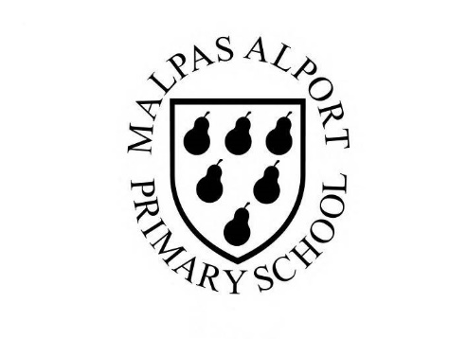
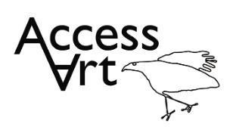
https://www.accessart.org.uk/explore-draw/

Autumn Term Year 1/2 Cycle B :  Explore and Draw |  | Topic: Drawing and Sketchbooks |  | Cultural Capital: Watch art videos online to increase access to places you are unable to visit. Visit local galleries, museums, crafts groups, artists.
National Curriculum Objectives (KS1):
- to use a range of materials creatively to design and make products
- to use drawing, painting and sculpture to develop and share their ideas, experiences and imagination
- to develop a wide range of art and design techniques in using colour, pattern, texture, line, shape, form and space
- to know about the work of a range of artists, craft makers and designers, describing the differences and similarities between different practices and disciplines, and making links to their own work.

Enquiry Question: How can we become open, curious, explorers of the world, and use what we find to inspire us to make art?
Previous Learning:
Year 1:
- Introduction to the idea that we can find inspiration from the things around us. That we can use things around us as subject matter and as materials.
Future Learning (KS2):
- Continue to develop understanding about where artists and ideas and inspiration. Develop visual literacy, drawing and sketchbook skills to enable an enquiring mind.
Lesson Theme | Retrieval | Learning Target: | Activity | Success Criteria | Vocabulary | Key Concepts
Lesson 1: Introduce explorers and collectors | How are artists inspired by their environment | To understand that artists find inspiration for artwork from their environment. | Pupils will become familiar with the idea that other artists are inspired by exploring and collecting things in and around their environment. They will record their thoughts and feelings about the artwork in their sketchbooks and will visually list places and things that they can explore and collect from school home and their local area. | I have seen how some artists explore the world around them to find inspiration. | Explore, Collect, ReSee, Imagine, Curious, | That artists explore the world, seeing things around them in new ways, and bring things back to their studios to help them make art.
Lesson 2: Explore and collect | How can I be inspired by my environment? | To explore my environment and collect things that inspire me. | Pupils will demonstrate their curiosity by exploring their playground or school area to collect items that inspire them. Pupils will play with the objects to create new shapes and patterns on the ground. Pupils will decide which objects to bring back to the classroom before continuing to play with pattern and composition. They will demonstrate sorting skills by grouping objects by colour, size, material, and type. Children will take photos of their arrangements and reflect on their gathering and documentation. | I have explored my local environment (school, home) and collected things that have caught my eye.  I can explore composition by arranging the things that I have collected.  I can talk about what I collected, and how and why I arranged the things I collected.  I can take photographs of my artwork and I can think about focus and light. | Present, Re-present, arrange, composition  Photograph, Focus, Light, Shade, | That we can go into our own environments, even when they are very familiar to us, and learn to see with fresh eyes and curiosity.
Lesson 3: Drawing in sketchbooks | How can I record the items I have collected through drawing? | To explore different drawing exercises to record the things you have collected. | Pupils will work in sketchbooks using a variety of media (hand-writing pens, pencils). They will draw the things that they collected in week 2, becoming familiar with exercises like continuous line drawing and feely drawing. They will begin to develop hand-eye coordination through slow drawing and understand that they can explore an object through touch. | I can use careful looking to practice observational drawing, and I can focus for 5 to 10 minutes.  I can hold an object and make a drawing focusing on the way it feels. | Observational Drawing, Close study, Draw slowly, Intention,  Pressure, Line, Mark, Page  Sense of Touch | That we can use the things we find to draw from, using close observational drawing.
Lesson 4 & 5: materials and mark making | How can I use a range of materials to explore mark making? | To use a range of materials to create lots of varied mark making drawings of natural objects around me. | Pupils will use the skills that they have picked up in previous weeks to create a finished drawing. They will be introduced to wax resist techniques and will start considering ‘composition’ when making work. | I can combine different drawing medias such as wax resist and watercolour, graphite and water, wax crayon and pencil in my observational drawings.  I can work small in my sketchbook and on large sheets of paper, exploring how I can use line, shape and colour in my work. | Wax resist, Graphite, Watercolour, Brusho, Pencil,  Mark making, Line, Tone, Shape, | That we can explore and use art materials, be inventive with how we use them, taking creative risks and enjoying accidents as well as planned successes.  We can use the shape of the page, and the way we arrange elements on the page, to create compositions that we like.
Lesson 6: Reflect, share, and discuss | How can I reflect on my drawings? | To display the work made through the half term and reflect on the outcomes. | Pupils will display their work in a clear space and reflect on the half term, sharing what they like and what they would like to try again through peer discussion. | I can talk about the work I have made with my classmates, sharing the things I thought were successful and thinking about the things I would like to try again. | Reflect, Present, Share, Discuss, Feedback | That when we reflect on our own work and the work of others, we can think about what we are good at and what we might do differently next time.
Learning Outside of the Classroom?
- Explore the local environment, collecting objects for drawing (leaves, twigs, shells etc). Arrange elements within the environment in new ways, Photograph.
Cross Curricular Opportunity:
- Geography: Adapt to explore habitats.
- Maths: Use language to develop understanding of patterns, sequence, symmetry, pictorial representation, repetition.
- Science: Identifying common and wild plants, trees, structures of plants, exploring local environments and habitats, seasons, planting and growing.
- PSHE: Peer discussion, Collaboration.

Impact/Assessment
- Monitored by sketchbook work, one to one or small group conversation, whole class discussion, final outcome.
- Identify any personal challenges preventing meeting “I Can” statements
- Identify any weaknesses common to many in class which might help identify areas you need to focus on again as a teacher.
- Identify areas of particular strength which might benefit from being developed.
- No grades to be applied, no learning objectives in the sketchbooks, no teacher marking in sketchbooks.

