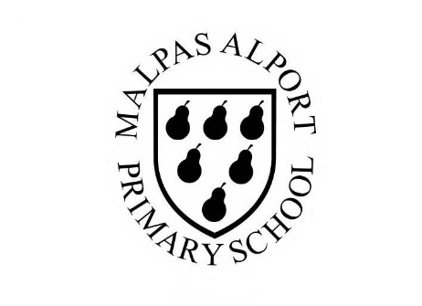
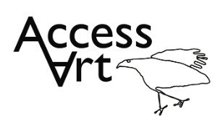
https://www.accessart.org.uk/playful-making/

Summer Term Year 1/2 Cycle A :  Playful Making |  | Topic: Working in 3 Dimensions |  | Cultural Capital: Watch art videos online to increase access to places you are unable to visit. Visit local galleries, museums, crafts groups, artists.
National Curriculum Objectives (KS1):
- to use a range of materials creatively to design and make products
- to use drawing, painting and sculpture to develop and share their ideas, experiences and imagination
- to develop a wide range of art and design techniques in using colour, pattern, texture, line, shape, form and space
- to know about the work of a range of artists, craft makers and designers, describing the differences and similarities between different practices and disciplines, and making links to their own work.

Enquiry Question: How can we transform the materials around us into sculpture?
Previous Learning:
Reception:
Future Learning (KS2):
- Further develop Design through Making skills, building understanding of the properties of materials, how we can use tools and ideas to transform them, and developing understanding of how other people might respond to what we make.
Lesson Theme | Retrieval | Learning Target: | Activity | Success Criteria | Vocabulary | Key Concepts
Lesson 1: Introducing sculpture | What is sculpture? | To identify what sculpture can be through discussion and drawing. | Pupils will become familiar with the term ‘sculpture’. Pupils will be introduced to the idea that sculptures are made by sculptors. They will be involved in discussion about the work with their peers. Pupils will create drawings inspired by the sculptures that they have seen. | I have explored what we mean by ‘sculpture’ and I have thought about what I like about different pieces of sculpture.  I can use my sketchbook to make drawings inspired by sculptured I have seen, to help me think about what I like, and to remember what I have seen. | Sculpture, Sculptor, Three Dimensions  Respond Response | That when we make art in 3 dimensions it is often called sculpture.  That I can form and share my opinions about a sculpture.
Lesson 2: Making | How can I manipulate materials? | To explore the qualities of a large range of making materials through open ended prompts. | Pupils will respond to prompts through making and constructing materials. They will demonstrate that they can experiment with materials without having a predefined outcome. Children will find out how they might attach more than one material together to construct new forms through trial and error. | I can use my hands to make small sculptures out of lots of different materials.  I can bend, fold, twist, cut and fasten materials together.  I can use my hands to make sculptures without designing first.  I can discover that sometimes working with materials is hard work – things break or my fingers hurt – but that’s okay. | Design Through Making, Playful Making, Explore, Construction,  Materials,  Invent, Imagine | That we can generate ideas through playful exploration.  That we can build understanding of the properties of materials through manipulation.
Lesson 3 & 4 & 5: | How can I use materials, tools, and ideas to invent? | To use materials to take creative risks, discover and invent without working towards a predefined outcome. | Pupils will apply what they found out about the properties of materials during lesson 2 and will push their exploration further by responding to the selected brief. Using their imaginations and hands, pupils will manipulate, build and invent sculptures. Sketchbooks will be used to record their findings. | I can bend, fold, twist, cut and fasten materials together.  I can use my hands to make sculptures without designing first.  I can use my sketchbook to respond to what I have learnt about materials. | Tools, Construct, Structure, Balance | That making sculpture is a partnership between materials, ideas, hands, and tools.  .
Lesson 6: Share, reflect, discuss | How can I reflect on my sculpture? | To display the work made through the half term and reflect on the outcomes. | Pupils will reflect on their sculptures over the half term, sharing what they like and what they would like to try again through peer discussion. Pupils will identify what they learnt about different materials. They may photograph their work and stick photos into their sketchbooks. | I can share my work and listen to what other people like about it.  I can look at other people’s work and sometimes share what I like about it with them. | Reflect, Share, Discuss | That we can reflect upon our intention when we see out ideas made physical.
Learning Outside of the Classroom?
- Identify & collect natural materials from the local environment to use in the sculptures.
Cross Curricular Opportunity:
- Geography: Adapt the playful making approach to make sculptures of ports and harbours, towns, cities, villages, The Great Wall of China etc.
- Maths: Uses language to support understanding of 2D/3D shapes, sequence, measuring, position & direction.
- Science: Uses language to support understanding of properties and manipulation of materials.
- PSHE: Collaboration, responsibility to the planet.
Impact/Assessment
- Monitored by sketchbook work, one to one or small group conversation, whole class discussion, final outcome.
- Identify any personal challenges preventing meeting “I Can” statements
- Identify any weaknesses common to many in class which might help identify areas you need to focus on again as a teacher.
- Identify areas of particular strength which might benefit from being developed.
- No grades to be applied, no learning objectives in the sketchbooks, no teacher marking in sketchbooks.

